### sh studrep

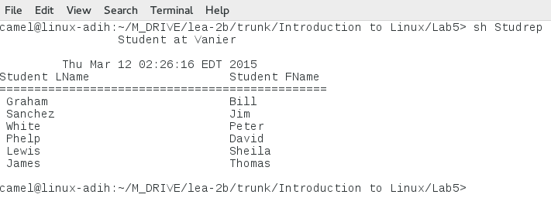

### ls –l /sbin | more

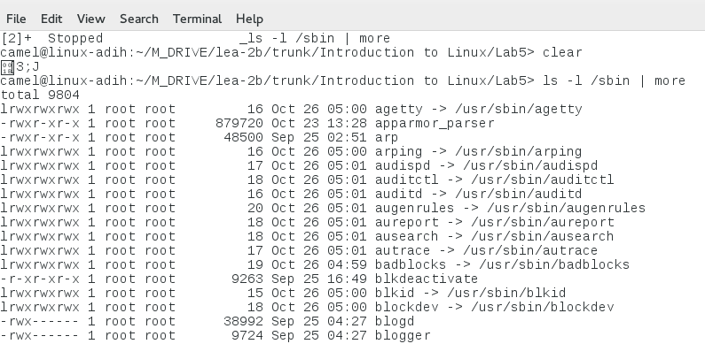

### grep could song1

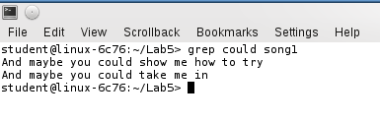

### grep -r Lewis *

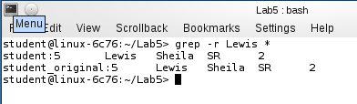

### sort product | uniq

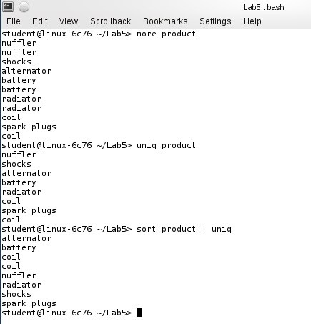

### comm product1 product2

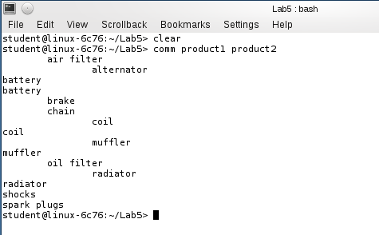

### diff faculty faculty2

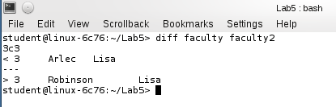

### wc faculty

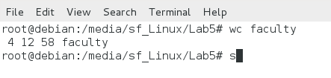

### sed -n 2,3p faculty > _facultyOut

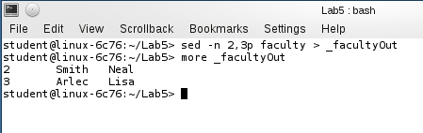

### sed -n -e 2,3d -e p faculty

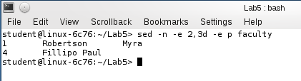

### sed -n -e s/Arlec/Robinson/p -n -e 2p faculty

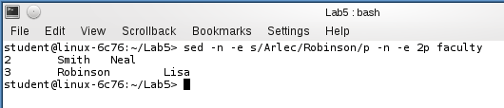

### tr [a-z] [A-Z] < faculty

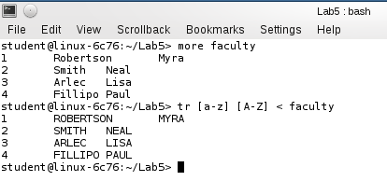

### sort -k 5 student > _student_sort

### join -1 5 -2 1 _student_sort faculty | grep Lisa | cut -d ' ' -f 2,3,4,5,1

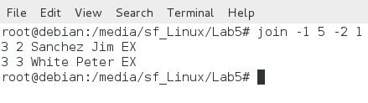

### wc student

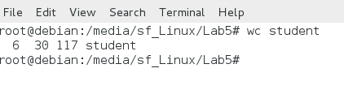

### sed -n 3,6p student

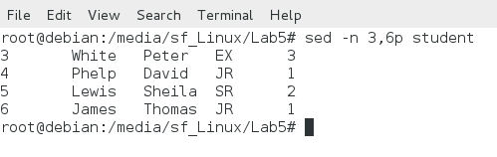

### tr [a-z] [A-Z] < product2

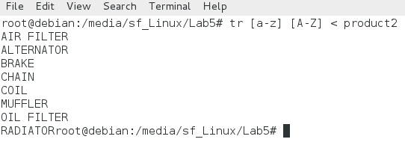

Page 247, Projects 5-6

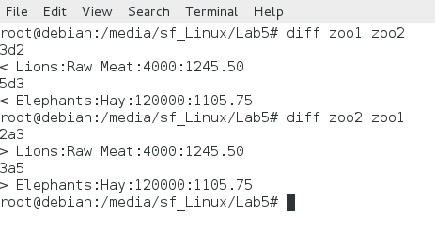

Page 250, Project 5-8

